

FirmWide IT Messaging

EMS Server Fault Tolerance

Best Practices Guide

Version | 1.0
Date | Jun 30, 2004
Author | Roshan D’Mello
Status | First Draft

Revision History
Version | Date | Author | Description
1.0 | Jun 30, 2004 | Roshan D’Mello | Original version of this document

Table of Contents

1. EMS Fault Tolerance - Overview 4
2. Co-residency of EMS Fault Tolerant Servers 5
3. EMS Shared State 5
4. Configuring Fault Tolerant Servers 6
5. EMS Reconnect Timeout 7
6. EMS Server Failure Detection 7
7. EMS Client Setup for Fault Tolerance 7
8. EMS Message Delivery for Queue Destination 8
9. Veritas Cluster Server (VCS) 9
10. Future Directions (Veritas CFS/CVM) 11

EMS Fault Tolerance - Overview

The TIBCO Enterprise Messaging Service (EMS) servers can be configured as a fault tolerant pair to provide for “software” fault tolerance in an environment. The primary server is the current active server, which accepts client connections, and processes message requests. The secondary server performs the role of a backup in case of failure. The primary and the secondary servers must both have access to the shared state to effectively perform as a fault tolerant pair. The shared state can be made available via shared storage devices or through other mechanisms such as replication. The shared state allows the secondary server to recover any active client connections and properly handle persistent messages for topic or queue destinations. During normal operation the primary and the secondary servers exchange heartbeats to ensure mutual availability. In addition the primary server also holds a lock on the shared state to prevent the secondary server from assuming the role of primary due to loss of heartbeats in the event of network failures.
When the primary server fails, the secondary server resumes operation and attempts to become the primary server. The secondary server detects the failure of the primary server due to loss of heartbeats and attempts to obtain lock on the shared state. The secondary server becomes primary only and only if it can obtain a lock on the shared state. If the secondary server fails to obtain a lock on the shared state it re-tries (EMS v4.1.0) the lock on the shared state until it is successful. Once the lock is obtained on the shared state the new primary server re-reads all of the configuration files. This helps the new primary server to be abreast of all configuration changes while it performed the role of a backup. The new primary server also recovers active clients connections, persistent messages from the shared store. The client applications if configured to be fault tolerant are seamlessly connected to the new primary server and continue normal operation. Only persistent messages are recovered on failure. Non-persistent messages cannot be recovered since they are persisted to main memory and not to the disk.
The whole objective of this document is to provide the best practices involved in configuring the EMS server instances as a fault tolerant pair keeping in mind key requirements:
- Availability
- Reliability
- Least time to fail over
- Ease of administration

Co-residency of EMS Fault Tolerant Servers

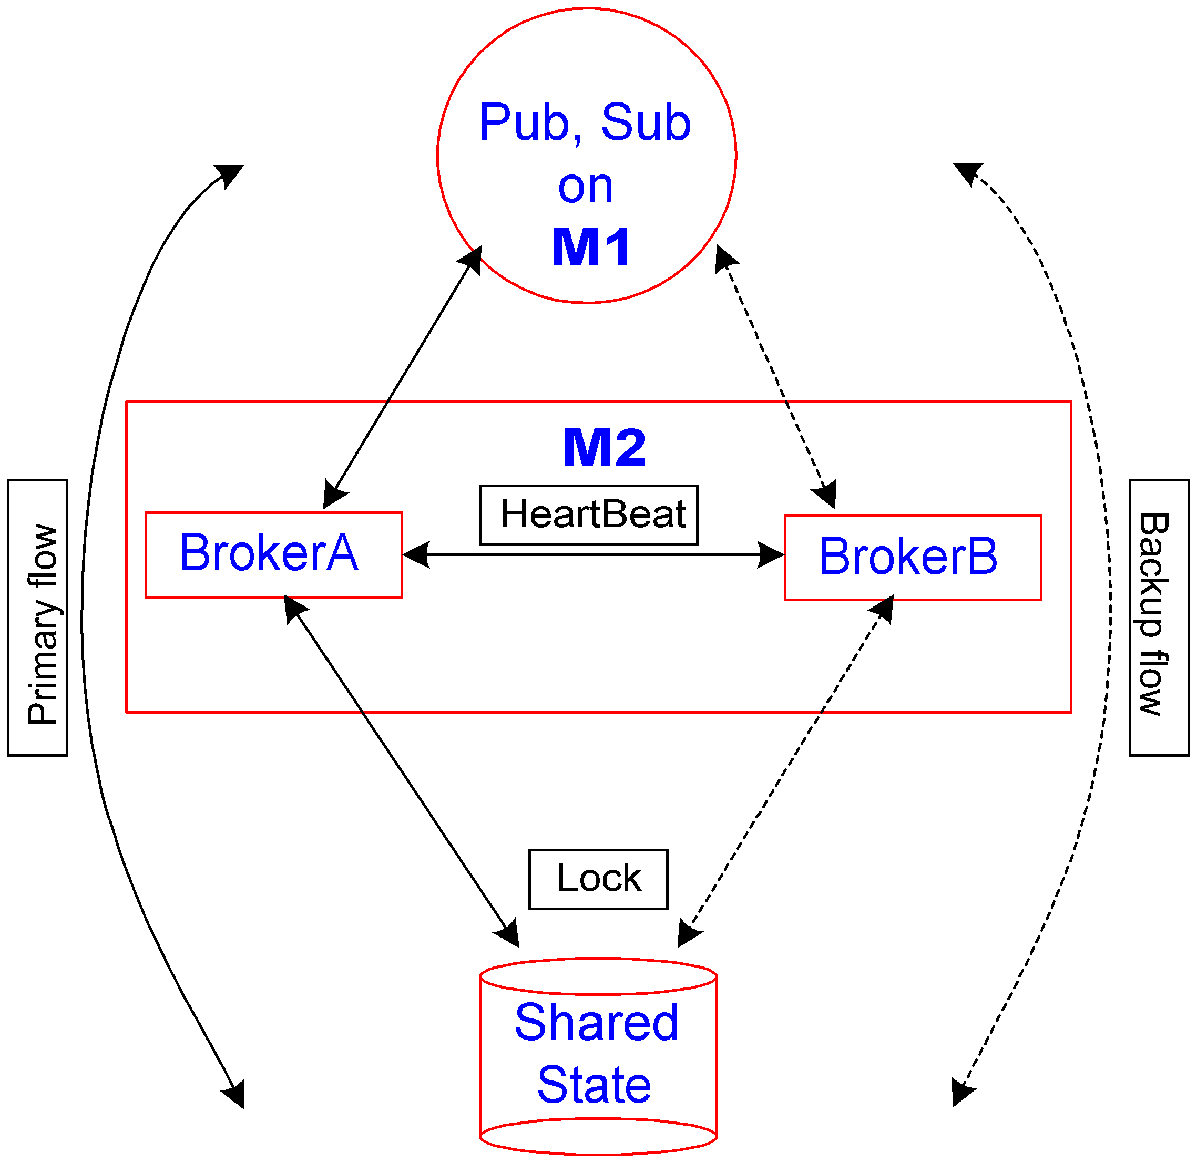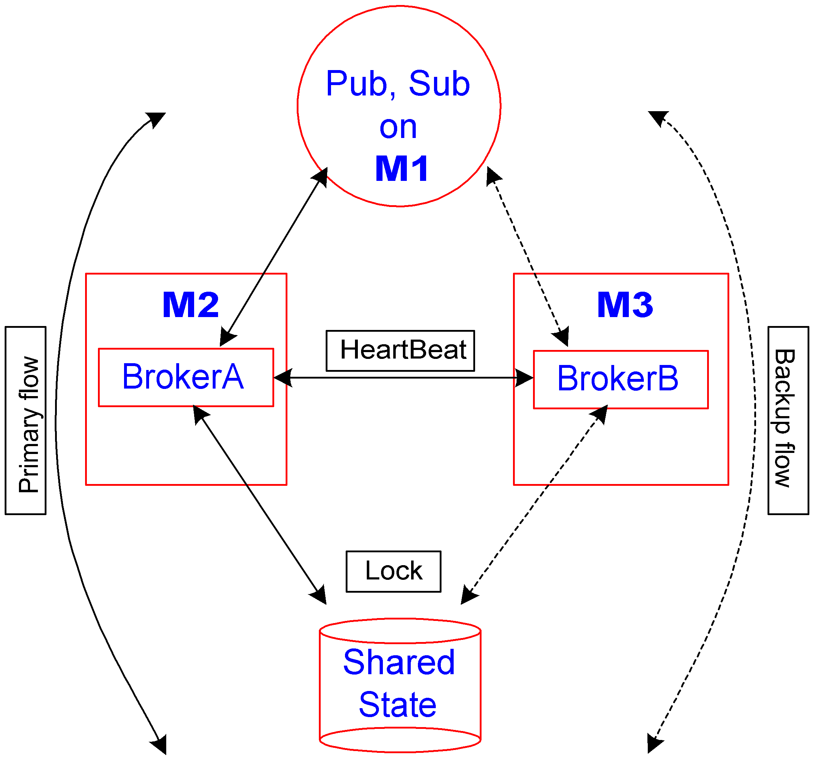
(a) Local (b) Remote
Figure. 1 Fault Tolerant Configuration

Figure. 1 above provides the two possible fault-tolerant configuration scenarios based on co-residency of the primary and the secondary server. For the purpose of the ensuing discussion consider BrokerA as primary server and BrokerB as secondary server.
Local Configuration:
- It is straightforward to implement the shared state since the servers BrokerA and BrokerB are co-resident and the shared state needs to be made available only to machine M2
- Failure of machine M2 forces the client application out of business
- Not a likely production scenario
Remote Configuration:
- Require a mechanism (VCS, CFS/CVM, Sistina Polyserve GFS) to implement the shared state since the shared state needs to be made available to either machine M2 or M3
- Failure of machine M2 can provide business continuity to client applications since the clients can be configured to automatically fail over from server “BrokerA” to server “BrokerB”
- Most realistic production scenario
It is apparent from the above discussion that (a) is not a practical solution and hence the rest of the discussion will focus on (b)

EMS Shared State

The shared state must be accessible to both the primary and the secondary servers. The shared state comprises:
- Persisted messages for queues and topics
- Information on the primary server’s active client connections
- Metadata regarding data delivery
During normal operation all persisted messages are stored then delivered. The primary server prevents the secondary server from unnecessarily assuming the role of the primary server by locking the shared state. During a fail over, the secondary server retrieves all shared state information, which is essentially the active client connections, and messages delivered using PERSISTENT delivery mode.
The shared state can be implemented by shared storage or through other means such as replication. Some common ways to implement shared storage is Storage Attached Network (SAN) or Network Attached Storage (NAS).
Replication schemes from popular vendors such as Veritas or EMC can be used for replicating the shared state. It is recommended that replication “not” be used since the secondary server may read the state from a separate location, ignoring the primary server’s lock on the state
The shared state is a collection of storage files. The location of the storage files is defined by the store parameter in the main configuration file. The storage files are namely:
- meta.db – Stores information for active client connections, durable subscriptions, message count for queues/topic destinations
- sync-msgs.db – Persistent store for queues and topic destinations defined as failsafe (synchronous I/O)
- async-msgs.db – Persistent messages for queue and topic destinations not defined as failsafe (asynchronous I/O)
Though TIBCO does not consider configuration to be part of the shared state it is highly recommended that the server configuration files (excepting the main server configuration file – tibemsd.conf) be co-resident with the storage files in the shared storage. This is achieved by assigning the shared storage location for the configuration files in the main server configuration file. The advantages of expanding the shared state to encompass the configuration files are two fold:
- Ease of configuration administration: Definition of destinations, routes, users, groups, acls, bridges, factories need to be done once and only once. It is “required” that any configuration changes be made only at the primary server which reflects changes to the configuration files in the shared storage. When the secondary server becomes the primary server it re-reads configuration from the shared store and hence is conscious about any changes in configuration while it performed the role of the backup
- Ease of Backup: The storage and the configuration files define a broker instance. In a catastrophic event a broker instance can be easily constructed if provided the storage and the configuration files. Having the storage and the configuration files in a central shared storage makes it simpler to automate backup operations
The main configuration file – tibemsd.conf must be local to the primary & the secondary server and should not be in the shared storage. This is a requirement because a server instance minimally requires the main configuration file to start and know its fault tolerant pair. Based on experiences with VCS, CFS shared storage is made available to a single machine at any moment in time. If the main configuration file is in the shared storage either of the primary or the secondary server will not be able to start causing a major failure in the fault tolerant setup.

Configuring Fault Tolerant Servers

A secondary server is configured as a fault tolerant backup to the primary server by setting the following configuration parameters in the secondary server main configuration file:
- server – Same name as the primary server
- ft_active – Set to the URL of the primary server
It is highly recommended that the primary server also set the ft_active parameter to the URL of the backup server. This allows the primary and the backup to exchange roles in the event of a failure

EMS Reconnect Timeout

When the secondary server assumes the role of the primary server during fail over, client applications that have been configured to be fault tolerant automatically reconnect to the backup server and continue normal operation. The server can be configured to clean up state information for any clients that have not yet connected after a specified amount of time. The ft_reconnect_timeout (secs) server wide configuration parameter specifies the client state information cleanup interval. It is recommended that this parameter be set to a maximum conceivable time required to process a message. This would allow the client to successfully fail over currently experiencing delay in re-connection to the server. Setting this parameter appropriately makes unnecessary clients re-connecting and performing the string of successive JMS setup operations (Connection, Session, MessageProducer/MessageConsumer).

EMS Server Failure Detection

The secondary server detects the failure of the primary in either of the two ways:
- Heartbeat failure: The primary server sends heartbeats to the secondary server to indicate that it is operational. When an intermittent network failure causes heartbeats to be lost, the secondary server can detect the interruption in the steady stream of heartbeats. Two configuration parameters need to be set in the main configuration file to determine the failure of the primary due to absence of heartbeats:
ft_heartbeat – Frequency of heartbeat exchange (minimum value: 1 sec)
ft_activation – The interval for which the secondary server attempts to become primary in the event it fails to receive heartbeat messages from the primary server. This value must be set to at least twice the heart beat interval (minimum value: 2 sec)
For applications that require instantaneous fail over it is highly recommended that the configuration parameters be set to its minimum as suggested above. Hence the earliest the secondary server attempts to become active is 2 sec due to the absence of heartbeats. The downside is the cost of increased network traffic due to frequent transmission of heartbeats. For networks that experience frequent intermittent failures the activation interval should be set appropriately large enough.
- Connection failure: If the primary server crashes or closes its TCP connections the secondary server instantaneously detects TCP connection failure

EMS Client Setup for Fault Tolerance

A client application can be configured to be Fault Tolerant to the failures of the server by providing a list of comma de-limited URLs as part of the connection to the server. Note that the same protocol needs to be used for connection to both the primary and the secondary server. Even though there are only two servers (primary and secondary) client applications can specify more than two URLs for connection. This can be useful is there is more than on listen address on each server. It is highly recommended that clients setup the following properties before attempting to connect:
connect_attempt_count – Applicable when the client application attempts to connect the first time
connect_attempt_delay – Applicable when the client application attempts to connect the first time
reconnect_attempt_count – Applicable when the client application was connected and is attempting to reconnect due to server failure
reconnect_attempt_delay - Applicable when the client application was connected and is attempting to reconnect due to server failure
Java client applications can request to be informed of the occurrence a fail over. This is accomplished by defining the system property tibco.tibjms.ft.switch.exception to any value. The application exception listener gets called in the event of a fail over.

EMS Message Delivery for Queue Destination

For load balanced consumer applications, messages that have been sent to multiple receivers, but have not been acknowledged before the fail over, may be sent to other receivers immediately after the fail over. A receiver trying to acknowledge a message after a fail over may receive the javax.jms.IllegalStateException. This exception signifies that the attempted acknowledgement is for a message that has already been sent to another queue receiver. This exception only occurs in this scenario or if the Session or Connection is closed. This exception cannot occur if there is only one receiver at the time of a failover, but it may occur for exclusive queues if more than one receiver was started for that queue. When the queue receiver encounters the javax.jms.IllegalStateException, the best course of action is to call the Session.recover() method which sets the state to the last successfully received message. Consumer applications should also be prepared to handle redelivery of messages in this event. All queue messages that can be redelivered to another queue receiver after a fail over always have JMSRedelivered header field set to true. Applications can check that field to avoid duplicate processing of the same message in the case of redelivery.
After a fail over, when a client attempts to call the Session.commit() method, the application will throw a javax.jms.TransactionRolledBackException. Clients that use transactions should account for this possibility and handle the exception in the event of a fail over.

Veritas Cluster Server (VCS)

It is important to note from our above discussion that a mechanism needs to be in place to make available the shared storage to the primary and the secondary server. Currently in CSFB VCS is the only mandated mechanism firm wide. This section provides details on the experience of the messaging team with VCS

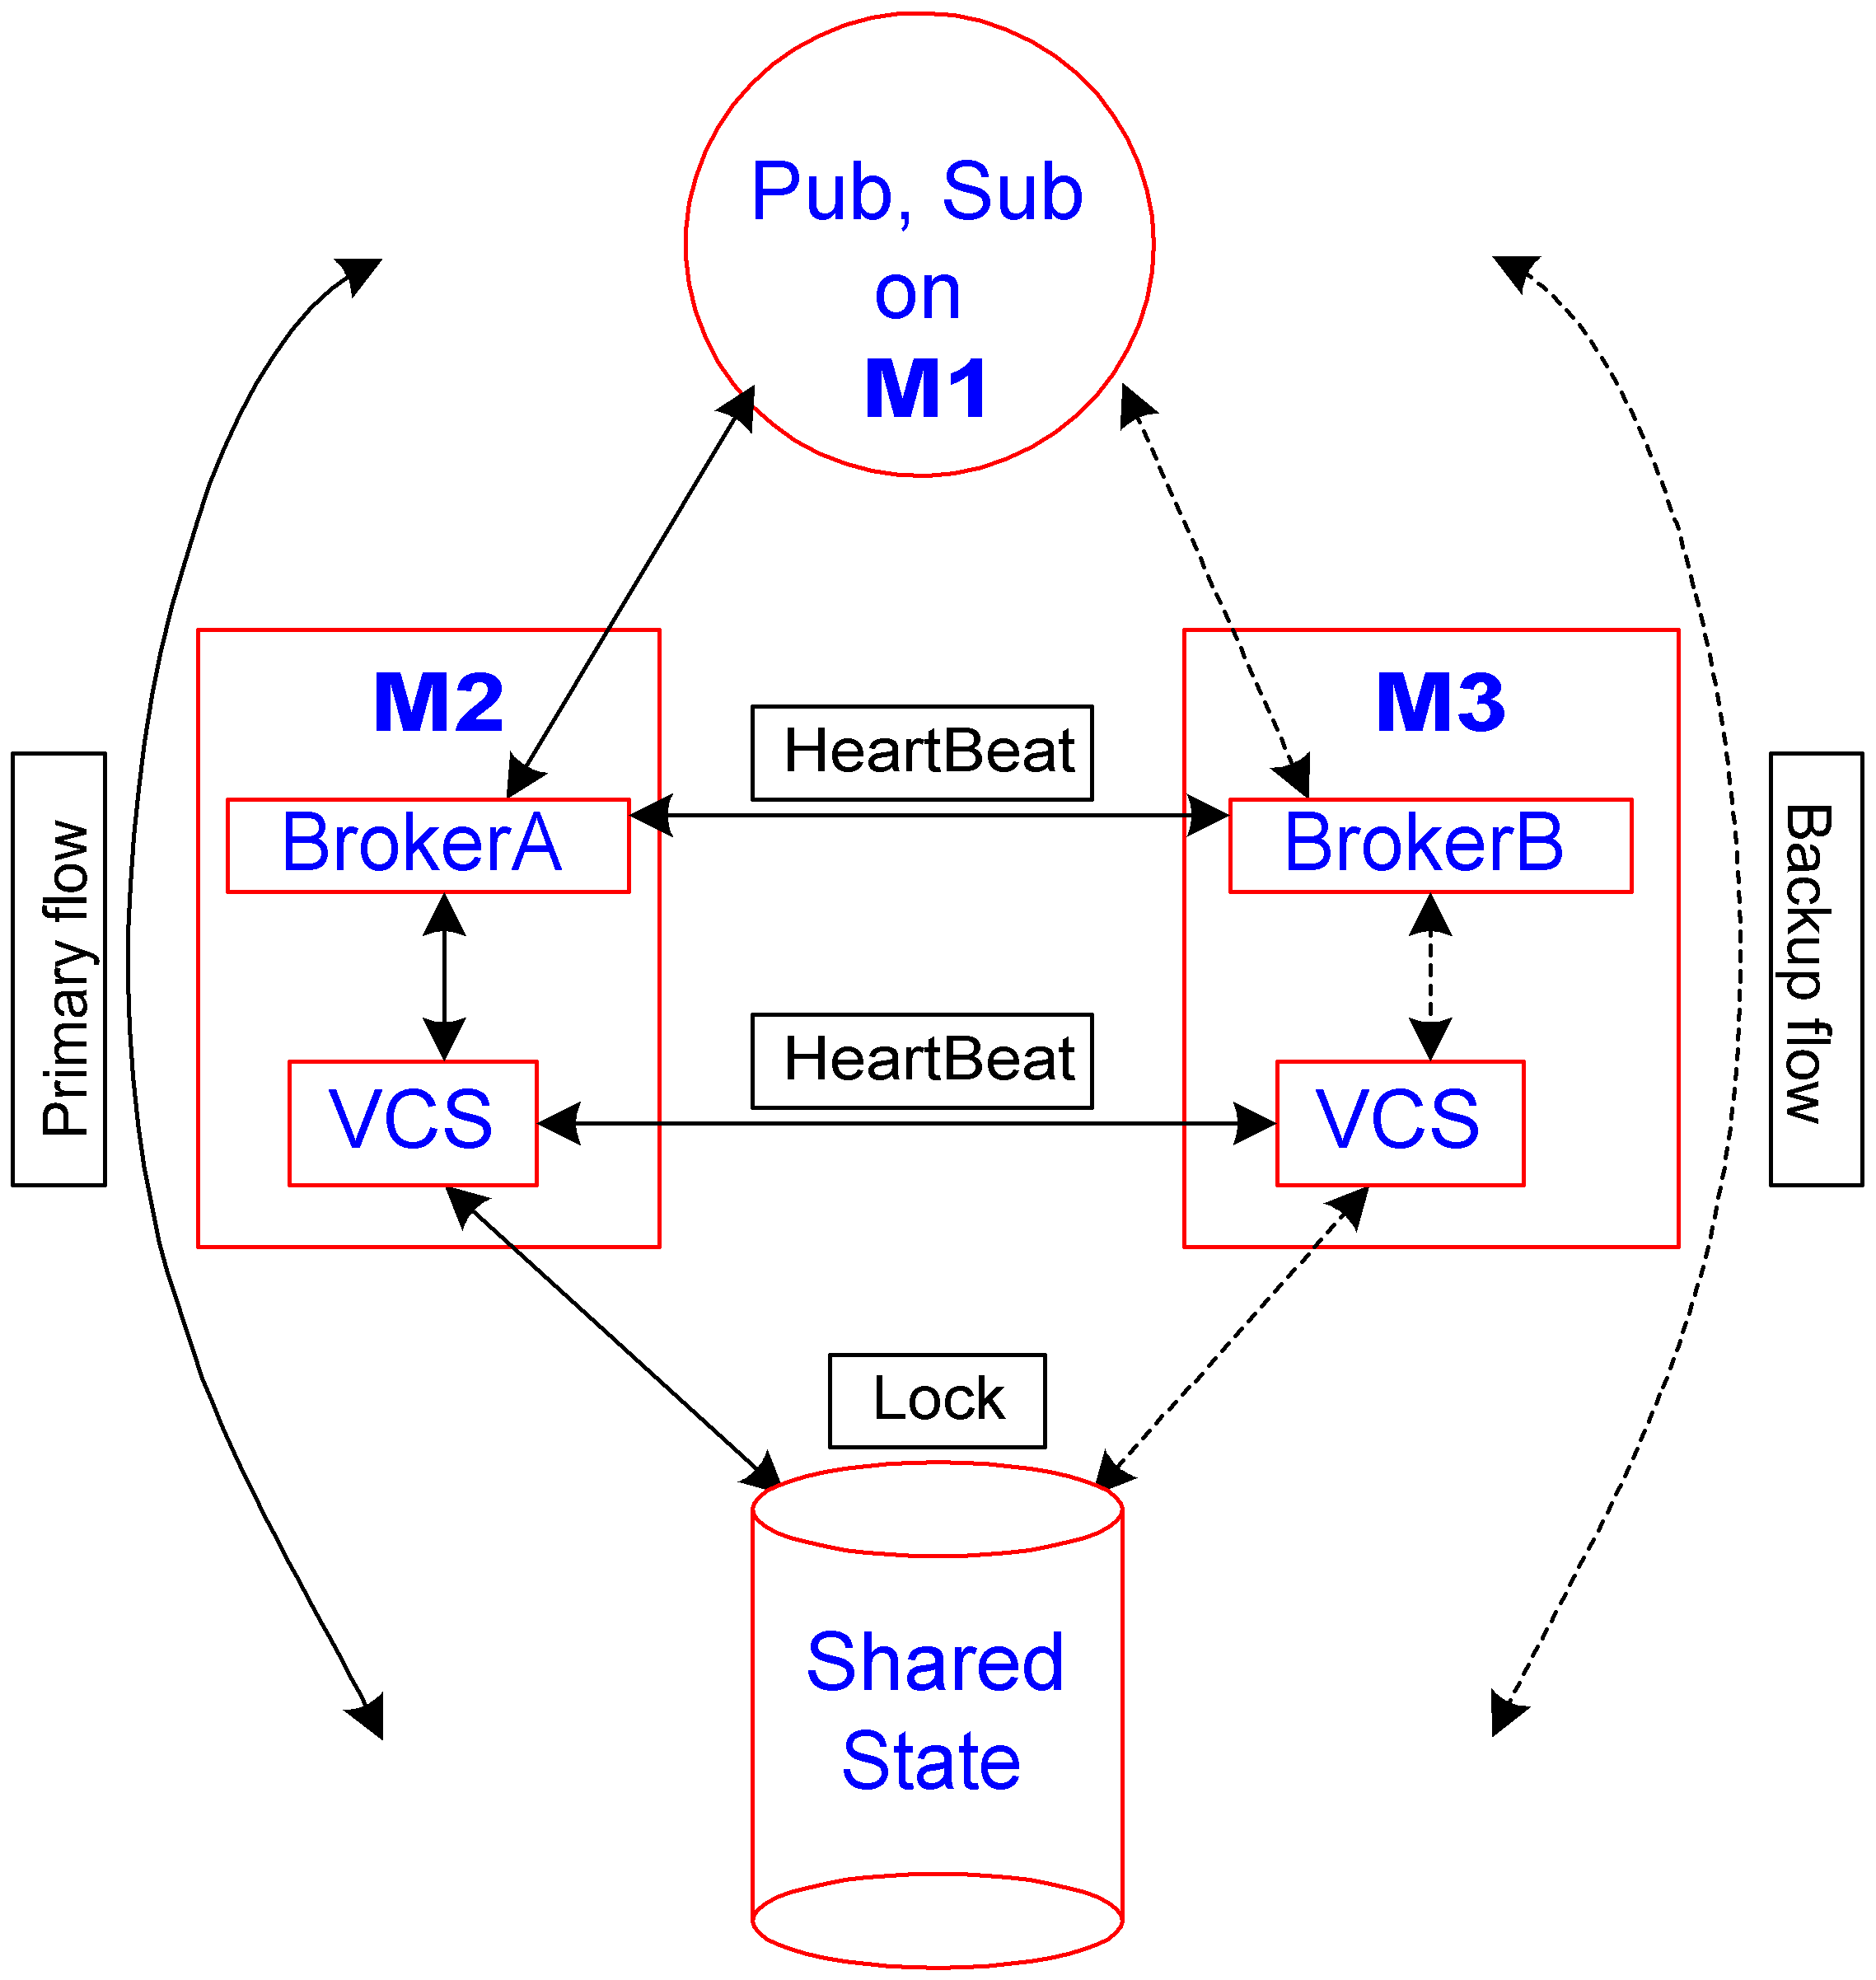

Figure. 2 Fault Tolerant Configuration with VCS

Figure. 2 above illustrates the fault tolerant setup with VCS. The following are the valuable lessons learnt based on the messaging teams experiences with VCS
- VCS requires registration of a service group, which is essentially a unit of fail over. The service group is expressed as a dependency tree of closely-knit resources (Disk Groups, Mount Point, EMS Server) and ensures that resources fail over as a unit and are brought up in the right order. The dependency tree established from left to right is:
Disk Groups → Mount Point →EMS Server
Note that for VCS to be used the file system needs to be formatted as a Veritas file system. When the primary VCS agent detects the failure of the primary server it unwinds the dependency list from right to left and notifies the secondary VCS agent of the shutdown. The secondary VCS agent builds the dependency tree from left to right. The secondary broker instance if running and configured as a fault tolerant pair obtains access to the shared storage no sooner the mount point is established
- VCS is not recommended for instantaneous fail over. This is due to the fact that there is no distributed lock management solution available in VCS. Hence the shared storage is not readily available (mounted) on the secondary server machine. If failure of the primary server is detected the primary & the secondary VCS agents takes considerable time (~12-15 sec) to make available the shared storage to the secondary broker.
- Only for EMS v4.0.0: In EMS v4.0.0 though expected, the feature of the server retrying the data store “forever” is not implemented. Hence the secondary server fails no sooner it detects the failure of the primary server. This is because the shared store has not yet made available to the secondary broker (This important feature is now available in EMS v4.1.0 and makes this point unnecessary)
- Only for EMS v4.0.0: Until the availability of v4.1.0 it is recommended that VCS be used to support an active-passive configuration. In this particular case the secondary server does not required to be configured as a fault tolerant pair and does not need to be running. The secondary VCS agent can be configured to start the secondary broker instance from scratch and recover the persisted messages. The down side of this configuration is that the client application connections will require reconnecting. (EMS v4.1.0 is now available and makes this point unnecessary)
See below the test environment setup and test results obtained with VCS:

Test Details:

- Platform: Linux-Egenera
- M2: emctords18
- M3: emctords19
- Data Store: /app/ems-store file partition is made available to both the machines M2 and M3. The data stores and configuration files for EMS will reside in this partition
- [M2|M3] connectivity to SAN attached storage: The connection from the machines to the disk is fiber (2gbps)
- M2 and M3 connectivity: Connections between the two machines is Egenera back plane
- Message Size: 1KB
- VCS Heart Beat: 60 ms
- EMS Heart Beat Interval: 1sec
- EMS Broker Activation Interval: 3 sec

Hardware Tests (Linux-Egenera):

Failure Type | No. Of Messages | Data Size  (MB) | Time for the backup broker to get access to the File System using VCS | EMS Recovery Time (secs) | Total Time (secs)
Reboot | 0 | 0 | 12 | 0 | 12
 | 100000 | 100 MB | 9 | 10 | 19
 | 200000 | 200 MB | 12 | 19 | 31
 | 300000 | 300 MB | 12 | 28 | 40
Graceful Shutdown (init 6) | 300000 | 300 MB | 12 | 29 | 41

Software Tests (Linux-Egenera):

Failure Type | No. Of Messages | Data Size  (MB) | Time for the backup broker to get access to the File System using VCS | EMS Recovery Time (secs) | Total Time (secs)
Graceful Shutdown | 300000 | 300 MB | 12 | 27 | 39
Kill | 300000 | 300 MB | 12 | 27 | 39
Kill –9 | 300000 | 300 MB | 11 | 28 | 39

Future Directions (Veritas CFS/CVM)

Cluster File System (CFS) / Cluster Volume Manager (CVM) from Veritas provides for distributed lock management. The conceivable advantage of such a solution is instantaneous fail over. This is due to the fact that the disk groups and mount point are already made available to both the primary and the secondary machine. However the CFS/CVM “lock” makes available the shared store only to the primary at any moment in time. In the event of a fail over the lock is manipulated accordingly so that the secondary server gets instantaneous access to the shared storage.
Please note that this needs to be tested, certified by GSE, GSI.
See below the test environment setup and test results obtained with Veritas CFS/CVM:

Test Details:

- Platform: Linux-Egenera
- M2: emctords18
- M3: emctords19
- Data Store: /app/ems-store file partition is made available to both the machines M2 and M3. The data stores and configuration files for EMS will reside in this partition
- [M2|M3] connectivity to SAN attached storage: The connection from the machines to the disk is a fiber (2gbps)
- M2 and M3 connectivity: Connections between the two machines is Egenera back plane
- Message Size: 1KB
- VCS Heart Beat: 60 ms
- EMS Heart Beat Interval: 1sec
- EMS Broker Activation Interval: 3 sec

Hardware Tests (Linux-Egenera):

Failure Type | No. Of Messages | Data Size  (MB) | Time for the backup broker to get access to the File System using CFS-CVM | EMS Recovery Time (secs) | Total Time (secs)
halt | 70000 | 70 MB | 0 | 2 | 7
Graceful Shutdown (init 6) | 70000 | 70 MB | 0 | 2 | 7

Software Tests (Linux-Egenera):

Failure Type | No. Of Messages | Data Size  (MB) | Time for the backup broker to get access to the File System using CFS-CVM | EMS Recovery Time (secs) | Total Time (secs)
Graceful Shutdown | 70000 | 70 MB | 0 | 2 | 2
Kill | 70000 | 70 MB | 0 | 2 | 2
Kill –9 | 70000 | 70 MB | 0 | 7 | 7

Note that the broker fail over time is sub-second. The total time to fail over is the broker state recovery time.

